LAFAYETTE ARTHRITIS AND ENDOCRINE CLINIC
4212 West Congress Street, Suite 2300A
Lafayette, LA 70506
PHONE (337) 237-7801
FAX (337) 233-2965

TODD BAQUET, M.D.

ENDOCRINOLOGY—Suite 2300B when you arrive for your appt

Dear Patient:

Welcome to Lafayette Arthritis and Endocrine Clinic. We are pleased that you have chosen us as your health care specialist, and look forward to seeing you at

_____________ ON ________________________________________________________________________
Time Day Date

The enclosed forms are necessary to open your medical record. These include the Patient Registration Form, Authorization to Release Information, Information for Your Physician and Notice of Privacy Practices forms. Please complete all forms, PRIOR to your visit, sign and date where indicated, and mail back to office at least one week prior to appointment so we may input data into our computer system. By doing so, your wait time, and the wait of those who are appointed after you, should be lessened.

Also, bring all of your current medications and insurance card(s) with you to our office for EVERY appointment, as well as all current imaging and lab work deemed pertinent by the referring physician. If you are diabetic, bring a log of your blood sugars from 1-2 weeks prior to visit. Bringing these items will help keep the cost of your visit down and may prevent having to repeat labs and imaging.

Please note: Your initial appointment will be with Dr. Todd Baquet. You will be seen by either Dr. Todd Baquet or our Nurse Practitioner at subsequent visits.

Our office requires a 24-hour cancellation notice. If you cannot make your scheduled appointment or need to reschedule, contact our office 24-hours prior. If we do not receive notice: YOU (not your insurance) will be billed for a missed appointment. Missed new patient appointments will be charged $50.00 and revisits $25.00. If an emergency occurs, please contact our office.

If you have any questions or need assistance with any of the questions on the forms, we will be glad to help you when you come or call us at 337-237-7801.

Again, welcome to our practice. We look forward to meeting you at your first appointment.

Sincerely,

Lafayette Arthritis and Endocrine Clinic

DIRECTIONS

THIS IS FOR YOU TO KEEP—DO NOT MAIL BACK TO US

LAFAYETTE ARTHRITIS AND ENDOCRINE CLINIC has moved!
Our new address is 4212 West Congress Street, Suite 2300A. Lafayette, LA 70506. (mailing)
Suite 2300B--when you arrive for your appt

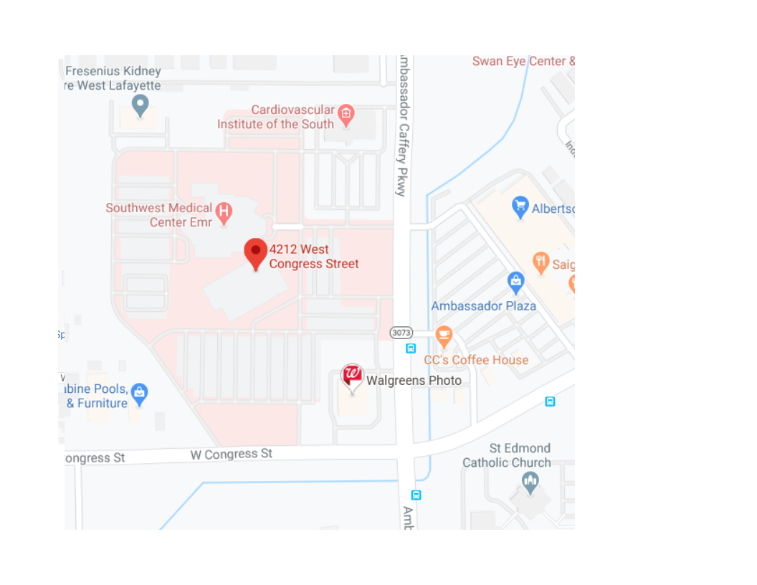

Information for your physician: Dr. Todd Baquet Date___/___/___
Please answer the following questions. It will help your physician to know about your health and family medical history.
Patients Name ___________________________ SS#________________________ Age______ Date of Birth ___/___/___
Address_________________________________ City_____________ State ___ Zip_____ Email _____________________
Home Phone (_____) _____-___________ Cell Phone (_____) _____-_________ Work Phone (_____) _____-__________
Place of Employment ________________________________________________ Occupation ______________________
Sex: Male___ Female___ Race _____Ethnicity______ Name of responsible party (if other than patient): _____________
Emergency Contact: __________________________________________________ Phone (____) ______-_____________
Living Age or age of death Present Health or cause of death
Father…..Yes ____ No ____ ________________________________ ________________________________
Mother… Yes ____ No ____ ________________________________ ________________________________
Spouse….Yes ____ No_____ ________________________________ ________________________________
Brothers # Living _________ Health__________________________________________________________________
# Dead _________ Cause of Death ___________________________________________________________
Sisters # Living _________ Health __________________________________________________________________
# Dead __________ Cause of Death ___________________________________________________________
Children Living ___________ Ages and Health __________________________________________________________
Children Dead ___________ Ages and Causes __________________________________________________________

Please circle illnesses which occurred in any of your Blood Relatives.
Diabetes Cancer Bleeding Tendency Kidney Disease Tuberculosis
Heart Disease Stroke High Blood Pressure Nervous Illness Arthritis

Please circle illnesses or condition you have had.
Diabetes Glaucoma Heart Trouble Hypertension Vein Trouble
Cancer Asthma Jaundice Arthritis Bleeding Tendency
Ulcers Pneumonia Kidney Disease Rheumatic Fever Nervous Disorder

Previous Operations: Please list, giving year, and hospital where performed. ___________________________________
__________________________________________________________________________________________________
__________________________________________________________________________________________________
Have you had serious injuries, broken bone, etc.? _________________________________________________________ List:_________________________________________________________________________________________________________________________________________________________________________________________________
Have you had allergy or sensitivity to medicine or other substances? __________________________________________
Please describe _____________________________________________________________________________________
Do you use Tobacco now? ________ In the past? ________ Daily amount? __________ How long? _________________
Alcohol use per week if any: ___________________________________________________________________________
Have you taken cortisone type drugs? _____________________________ Oral Contraceptives? ____________________
What is your main medical problem at the present time? ___________________________________________________
List current medications, dose and frequency? ____________________________________________________________
__________________________________________________________________________________________________
__________________________________________________________________________________________________
Name of referring physician: __________________________________________________________________________
If not referred, would you like a report sent to your family physician ______Yes _____No
Name of family physician: _____________________________________________________________________________
LAFAYETTE ARTHRITIS AND ENDOCRINE CLINIC
PATIENT CONFIDENTIALITY QUESTIONNAIRE

Patient Name_________________________________ Date of Birth_____________________

1. Can confidential messages be left on your telephone answering machine?

YES__________ NO__________

2. Please print the telephone number(s) where you want to receive calls about your appointments, lab results, x-ray results and other health care information if other than your home phone number. (This could be a work number or cellular number.)
*I am fully aware that a cell phone is not a secure and private line.

(________)__________________________

(________)__________________________

3. Please list the family members or other persons, if any, whom we may inform about your general medical condition and your diagnosis (including treatment, payment and health care operations).

____________________________________________________________________________________________________________________________________________________________________________________

4. If the patient is under the age of 18, please list all family members who will be allowed to request medical services for and/or accompany the patient when receiving medical services. (If someone other than the individual(s) listed below accompanies the patient in the future, a note from a parent or guardian must accompany that individual.)

____________________________________________________________________________________________________________________________________________________________________________________
I am fully aware that my health care information can be transmitted by electronic transmission, by fax transmittal, by internet or by e-mail.

I understand that this information is effective with the date of signing and that changes in this information will require completion of a new form and are my responsibility.

Patient Signature:_____________________________________________Date:_________________
(Guardian if under age 18 years)
Lafayette Arthritis and Endocrine Clinic

NOTICE OF PRIVACY PRACTICES ACKNOWLEDGEMENT

I understand that, under the Health Portability & Accountability Act of 1996 (HIPAA), I have certain rights to privacy regarding my protected health information can and will be used to:
a. Conduct, plan and direct my treatment and follow-up among the multiple healthcare providers who
may be involved in that treatment directly and indirectly.
b. Obtain payment from third-party payers.
c. Conduct normal healthcare operations such as quality assessments and physician certifications.

I acknowledge that I have received your Notice of Privacy Practices containing a more complete description of the uses and disclosures of my health information. I understand that this organization has the right to change its Notice of Privacy Practices from time to time and that I may contact this organization at any time at the address above to obtain a current copy of the Notice of Privacy Practices.

I understand that I may request in writing that you restrict how my private information is used or disclosed to carry out treatment, payment or healthcare operations. I also understand you are not required to agree to my requested restrictions, but if you do agree then you are bound to abide by such restrictions.

Patient Name ___________________________________________
Relationship ____________________________________________
Signature _____________________________________________
Date _____________________________________________

OFFICE USE ONLY

I attempted to obtain the patient’s signature in acknowledgement of the Notice of Privacy Practices Acknowledgement, but was unable to do so as documented below:

___________________________ ______________________________
Employee Printed Name Employee Signature

___________________________
Date

Lafayette Arthritis and Endocrine Clinic

Authorization to Release Information
I hereby authorize Lafayette Arthritis and Endocrine Clinic, or any holder of medical information about me to release to the Health Care Financing Administration and Its agents (Medicare) or Insurance Companies or Third Parties, any information needed to determine these benefits or the benefits payable for related services.

Assignment of Benefits

I request that authorized Medicare or Insurance payments of medical benefits be made to Lafayette Arthritis and Endocrine Clinic (to be used only if necessary to file claims).

Guarantor Responsibility

I understand that I am ultimately responsible for payment of any and all charges for medical services rendered by Lafayette Arthritis and Endocrine Clinic, and if this assignment is rejected, modified, or not paid within a reasonable time after it has been filed, it will be my responsibility to pay any unpaid charges in full. If it is necessary to collect unpaid fees for services rendered, I agree to pay the charge assessed by the collection service, legal counsel or court.

This authorization and assignment may be revoked by me at any time by a written notice. I agree that a photocopy of this form may be used in lieu of the original.

Acknowledgment of Receipt of Notice of Privacy Practices

I hereby acknowledge that I have received the Notice of Privacy Practices, describing the privacy practices and safeguard as well as my right with respect to my protected health information maintained and used by Lafayette Arthritis and Endocrine Clinic.

______________________________ _____________
Signature of Insured/Patient Date

*PLEASE PRINT* Date: ___________________

PATIENT INFORMATION

PATIENT NAME: ___________________________________________________________________________________
LAST FIRST MIDDLE

MALE____ FEMALE____ ______/_______/_______ __________-________-_____________
SEX DATE OF BIRTH S.S NUMBER

GUARANTOR INFORMATION

GUARANTOR NAME: _______________________________________________________________________________
ADDRESS: ___________________________________________________________________________________
CITY: ______________________________ STATE: ____________________________ ZIP CODE: ______________
HOME PHONE: (____) ________________ WORK/CELL: (____) _______________ EXT: ____________________

PRIMARY INSURANCE

INSURANCE TYPE: Medicare Medicaid Medigap Workers Comp Group Individual
Commercial Litigation Supplement Long Term Auto Other: ___________

IC#_______________ CARRIER NAME: ______________________________ CARRIER PHONE: ______________________
PATIENT RELATIONSHIP TO SUBSCRIBER
(CIRCLE ONE):
1 Male Patient is subscriber
2 Female Patient is subscriber
3 Male Spouse of subscriber
4 Female Spouse of subscriber
5 Male Child of subscriber
6 Female Child of subscriber
7 Other:

CARRIER ADDRESS: __________________________________________________________________________________
SUBSCRIBER INFORMATION:___________________________________________________________________________
LAST NAME FIRST NAME MIDDLE INITIAL
MALE____ FEMALE___ _______/______/ _________ _________-________-______________
SEX DATE OF BIRTH S.S.NUMBER
MAIL CLAIM TO: (CIRCLE ONE) INSURANCE CO. EMPLOYER PATIENT
EMPLOYER: ______________________________________________ EMPLOY PHONE: ___________________________
EMPLOYER ADDRESS: ________________________________________________________________________________
INS. POLICY#: ________________________________________ INS. GROUP# ___________________________________

SECONDARY INSURANCE

INSURANCE TYPE: Medicare Medicaid Medigap Workers Comp Group Individual
Commercial Litigation Supplement Long Term Auto Other: ___________

IC#_______________ CARRIER NAME: ______________________________ CARRIER PHONE: ______________________
PATIENT RELATIONSHIP TO SUBSCRIBER
(CIRCLE ONE):
1 Male Patient is subscriber
2 Female Patient is subscriber
3 Male Spouse of subscriber
4 Female Spouse of subscriber
5 Male Child of subscriber
6 Female Child of subscriber
7 Other:

CARRIER ADDRESS: __________________________________________________________________________________
SUBSCRIBER INFORMATION:___________________________________________________________________________
LAST NAME FIRST NAME MIDDLE INITIAL
MALE____ FEMALE___ _______/______/ _________ _________-________-______________
SEX DATE OF BIRTH S.S.NUMBER
MAIL CLAIM TO: (CIRCLE ONE) INSURANCE CO. EMPLOYER PATIENT
EMPLOYER: ______________________________________________ EMPLOY PHONE: ___________________________
EMPLOYER ADDRESS: ________________________________________________________________________________
INS. POLICY#: ________________________________________ INS. GROUP# ___________________________________

EMERGENCY INFO: A friend or relative (Not responsible party)
NAME: _______________________________ RELATIONSHIP: _____________________PHONE: ____________________
ADDRESS: ______________________________________________ CITY, STATE, ZIP: _____________________________

OFFICE USE ONLY-DO NOT WRITE BELOW THIS LINE
REFERRING DOCTOR: ____________________ REF DR #: _________________________ PATIENT #: _________________
LAEC DOCTOR: _________________________ DR #: ____________________________ PATIENT TYPE:_______________

Medical History Update

Patient Name___________________________________ Date of Birth_____________________________

Past Medical History: Indicate Diagnosis with X

____Anemia
____Adrenal Failure __Adrenal Mass
____Anxiety/Depression
____Arthritis ____Rheumatoid ____Osteoarthritis
____Alcoholism
____Blood Clot/PE
____Broken Bones
____Cancer (type)__________________
____Diabetes
____Digestive
____Acid Reflux ____Ulcer ____Gallstones
____Foot Ulcers
____Fibromyalgia
____Heart Arrhythmia
____Heart Attack/MI
____Heart Failure
____Hemochromatosis
____High Blood Pressure
____High Cholesterol
____High Triglycerides
____Kidney Disease
____Liver Disease
____Lung Disease
____Asthma ____COPD/Emphysema ____TB
____Osteoporosis
____Prostate Disease
____Sarcoidosis
____Sickle Cell
____Sleep Apnea
____Stroke
____Thyroid Disease
____Hyperthyroid ____Hypo ____Thyroid Nodules
____Thyroid Cancer
____Vision Problems
____Cataract ____Glaucoma ____Retinopathy

Surgical History: Indicate with X and Date
Date (month/year-if known)
____Abdominal _____/_____
____Colon _____/_____
____Hernia _____/_____
____Appendicitis _____/_____
____Gallbladder _____/_____
____Brain Surgery _____/_____
____Parathyroid Surgery _____/_____
____Pituitary _____/_____
____Brain Tumor _____/_____
____Heart Surgery _____/_____
____Bypass _____/_____
____Stents _____/_____
____Valve Replacement _____/_____
____Vascular Surgery _____/_____
____Vein Stripping _____/_____
____Aneurysm Repair _____/_____
____Neck Surgery _____/_____
____Thyroid _____/_____
____Parathyroid _____/_____
____Lung Surgery _____/_____
____Joint/Bone Surgery _____/_____
____Neck _____/_____
____Back _____/_____
____Shoulder _____/_____
____Knees _____/_____
____Hip _____/_____
____Foot _____/_____
____Tonsils/Adenoids _____/_____
____GYN/ Urinary _____/_____
____Kidney _____/_____
____Hysterectomy _____/_____
____Breast _____/_____
____Bladder _____/_____
____Prostate _____/_____
____Eye Surgery _____/_____
____Laser _____/_____
____Cataract _____/_____

Medical History Update

GYN and Obstetrical
____# of live births _________Last menstrual period ____polycystic ovaries
____# of pregnancies

Recent Hospitalizations: month/year and diagnosis___________________________________________
____________________________________________________________________________________________
Please indicate status of immediate family: A-alive D-deceased (age of death)
Father_________ Mother _________ Sisters (how many) ________ Brothers (how many) __________
Children_________

Family History: (Place M, F, S, C where applicable)

(M-mother, F-father, S-sibling, C-child)

____Cancer (type) _______ ____ Diabetes ____Heart Disease ____Hemochromatosis
____High Cholesterol ____Hypertension ____Osteoarthritis ____Mental Illness
____Kidney Disease ____Lupus ____Osteoporosis ____Stroke
____Rheumatoid Arthritis ____Thyroid Disease ____Thyroid Cancer ____Depression

Social History (Please circle)
Married Single Divorced Widowed
Tobacco Status: (Check all that apply)
____Nonsmoker ____Smoker ____Former Smoker
Product:
____Cigarettes ____Chew ____Pipe
How much/often do you exercise? _________________________________________________________________
Have you used recreational drugs? ________________________________________________________________
If so, which ones? ______________________________________________________________________________
Alcohol: (Please circle that which applies)
____no alcohol ____Drinks/ounces daily/weekly/month
Number of Children______
Occupation ___________________________________________
Live alone ____________ With family ______________________

LIST ALL PHYSICIANS THAT YOU SEE REGULARLY
PHYSICIAN SPECIALTY LOCATION (city or town)
___________________________________ PRIMARY CARE ___________________________
___________________________________ _________________ ___________________________
___________________________________ _________________ ___________________________
___________________________________ _________________ ___________________________

Vaccines
Flu (date) ___________________________ Pneumonia (year) __________ Shingles (year)__________
Allergies: Please list medicine to which you have had a reaction________________________________________
___________________________________________________________________________________________

Please list medications that you have taken in the past that have caused side effects or have not worked for you.
Medication__________________________ What happened ______________________________________
___________________________________ ____________________________________________________

Lafayette Arthritis and Endocrine Clinic
Dr Todd Baquet

Cancellation Policy/No Show Policy for All Appointments

Cancellation/ No Show Policy for Doctor Appointment
We understand that there are times when you must miss an appointment due to emergencies or obligations for work or family. However, when you do not call to cancel an appointment, you may be preventing another patient from getting much needed treatment. Conversely, the situation may arise where another patient failed to cancel and we are unable to schedule you for a visit, due to a seemingly “full” appointment book.
If an appointment is not cancelled at least 24 hours in advance you will be charged a twenty-five dollar ($25) fee: this will not be covered by your insurance company.

Scheduled Appointments
We understand that delays can happen however we must try to keep the other patients and doctors on time.
If a patient is 15 minutes past their scheduled time we will have to reschedule the appointment.

Cancellation/No Show Policy for New Patients
Due to the large block of time needed for new patients, last minute cancellations can cause problems and added expenses for the office.
If appointment is not cancelled at least 24 hours in advance you will be charged a fifty-dollar ($50) fee: this will not be covered by your insurance company.

Account Balances
We will require that patients with self-pay balances do pay their account balances to zero (0) prior to receiving further services by our practice.
Patients who have questions about their bills or who would like to discuss a payment plan option may call and ask to speak to a billing office representative with whom they can review their account and concerns.
Patients with balances over $100 must make payment arrangements prior to future appointments being made.

____________________________________ ______________________ ____/___/____
Print Name--Patient Signature Patient/Guardian Date

Patient Account # _____________________
(Office Use Only)

