LAFAYETTE ARTHRITIS AND ENDOCRINE CLINIC
4212 West Congress St, Suite 2300A
Lafayette, LA 70506
(337) 237-7801
FAX (337) 235-1865

JENNIFER MALIN, M.D.

RHEUMATOLOGY

Dear Patient: _____________________________________________________________________________

Welcome to Lafayette Arthritis and Endocrine Clinic. We are pleased that you have chosen us as your health care specialist, and look forward to seeing you at

_____________ ON ________________________________________________________________________
Time Day Date

The enclosed forms are necessary to open your medical record. These include the Patient Registration Form, Authorization to Release Information, Information for Your Physician and Notice of Privacy Practices forms. Please complete all forms, PRIOR to your visit, sign and date where indicated, and mail back to office at least one week prior to appointment so we may input data into our computer system. By doing so, your wait time, and the wait of those who are appointed after you, should be lessened.

Also, bring all of your current medications and insurance card(s) with you to our office for EVERY appointment, as well as all current imaging and lab work deemed pertinent by the referring physician. Bringing these items will help keep the cost of your visit down, and may prevent having to repeat labs and imaging.

Please note: Your initial appointment will be with Dr. Jennifer Malin. You will be seen by either Dr. Jennifer Malin or our Nurse Practitioner at subsequent visits.

Our office requires a 24-hour cancellation notice. If you cannot make your scheduled appointment or need to reschedule, contact our office 24-hours prior. If we do not receive notice: YOU (not your insurance) will be billed for a missed appointment. Missed new patient appointments will be charged $50.00 and revisits $25.00. If an emergency occurs, please contact our office.

If you have any questions, or need assistance with any of the questions on the forms, we will be glad to help you when you come, or call us at 337-237-7801.

Again, welcome to our practice. We look forward to meeting you at your first appointment.

Sincerely,

Lafayette Arthritis and Endocrine Clinic

Directions

THIS IS FOR YOU TO KEEP---DO NOT MAIL BACK TO US

LAFAYETTE ARTHRITIS AND ENDOCRINE CLINIC has moved!
Our new address is now 4212 West Congress Street, Suite 2300A. Lafayette, LA 70506.

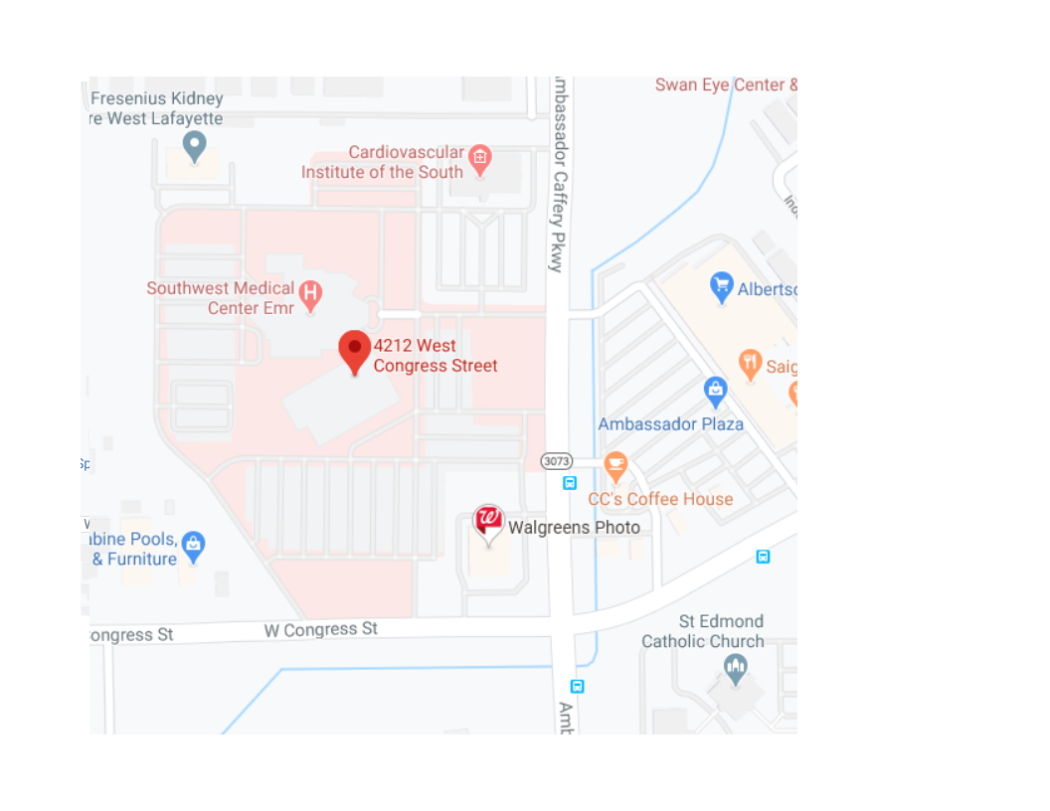

Information for your physician: Dr. Jennifer Malin Date___/___/___
Please answer the following questions. It will help your physician to know about your health and family medical history.
Patients Name ___________________________ SS#________________________ Age______ Date of Birth ___/___/___
Address_________________________________ City_____________ State ___ Zip_____ Email _____________________
Home Phone (_____) _____-___________ Cell Phone (_____) _____-_________ Work Phone (_____) _____-__________
Place of Employment ________________________________________________ Occupation ______________________
Sex: Male___ Female___ Race _____Ethnicity______ Name of responsible party (if other than patient): _____________
Emergency Contact: __________________________________________________ Phone (____) ______-_____________
Living Age or age of death Present Health or cause of death
Father…..Yes ____ No ____ ________________________________ ________________________________
Mother… Yes ____ No ____ ________________________________ ________________________________
Spouse….Yes ____ No_____ ________________________________ ________________________________
Brothers # Living _________ Health__________________________________________________________________
# Dead _________ Cause of Death ___________________________________________________________
Sisters # Living _________ Health __________________________________________________________________
# Dead __________ Cause of Death ___________________________________________________________
Children Living ___________ Ages and Health __________________________________________________________
Children Dead ___________ Ages and Causes __________________________________________________________

Please circle illnesses which occurred in any of your Blood Relatives.
Diabetes Cancer Bleeding Tendency Kidney Disease Tuberculosis
Heart Disease Stroke High Blood Pressure Nervous Illness Arthritis

Please circle illnesses or condition you have had.
Diabetes Glaucoma Heart Trouble Hypertension Vein Trouble
Cancer Asthma Jaundice Arthritis Bleeding Tendency
Ulcers Pneumonia Kidney Disease Rheumatic Fever Nervous Disorder

Previous Operations: Please list, giving year, and hospital where performed. ___________________________________
__________________________________________________________________________________________________
__________________________________________________________________________________________________
Have you had serious injuries, broken bone, etc.? _________________________________________________________ List:_________________________________________________________________________________________________________________________________________________________________________________________________
Have you had allergy or sensitivity to medicine or other substances? __________________________________________
Please describe _____________________________________________________________________________________
Do you use Tobacco now? ________ In the past? ________ Daily amount? __________ How long? _________________
Alcohol use per week if any: ___________________________________________________________________________
Have you taken cortisone type drugs? _____________________________ Oral Contraceptives? ____________________
What is your main medical problem at the present time? ___________________________________________________
List current medications, dose and frequency? ____________________________________________________________
__________________________________________________________________________________________________
__________________________________________________________________________________________________
Name of referring physician: __________________________________________________________________________
If not referred, would you like a report sent to your family physician __________________________ Yes ____ No
Name of family physician: _____________________________________________________________________________
LAFAYETTE ARTHRITIS AND ENDOCRINE CLINIC
PATIENT CONFIDENTIALITY QUESTIONNAIRE

Patient Name_________________________________ Date of Birth_____________________

1. Can confidential messages be left on your telephone answering machine?

YES__________ NO__________

2. Please print the telephone number(s) where you want to receive calls about your appointments, lab results, x-ray results and other health care information if other than your home phone number. (This could be a work number or cellular number.)
*I am fully aware that a cell phone is not a secure and private line.

(________)__________________________

(________)__________________________

3. Please list the family members or other persons, if any, whom we may inform about your general medical condition and your diagnosis (including treatment, payment and health care operations).

____________________________________________________________________________________________________________________________________________________________________________________

4. If the patient is under the age of 18, please list all family members who will be allowed to request medical services for and/or accompany the patient when receiving medical services. (If someone other than the individual(s) listed below accompanies the patient in the future, a note from a parent or guardian must accompany that individual.)

____________________________________________________________________________________________________________________________________________________________________________________
I am fully aware that my health care information can be transmitted by electronic transmission, by fax transmittal, by internet or by e-mail.

I understand that this information is effective with the date of signing and that changes in this information will require completion of a new form and are my responsibility.

Patient Signature: _____________________________________________Date: _________________
(Guardian if under age 18 years)
LAFAYETTE ARTHRITIS AND ENDOCRINE CLINIC

NOTICE OF PRIVACY PRACTICES ACKNOWLEDGEMENT

I understand that, under the Health Portability & Accountability Act of 1996 (HIPAA), I have certain rights to privacy regarding my protected health information can and will be used to:
a. Conduct, plan and direct my treatment and follow-up among the multiple healthcare providers who
may be involved in that treatment directly and indirectly.
b. Obtain payment from third-party payers.
c. Conduct normal healthcare operations such as quality assessments and physician certifications.

I acknowledge that I have received your Notice of Privacy Practices containing a more complete description of the uses and disclosures of my health information. I understand that this organization has the right to change its Notice of Privacy Practices from time to time and that I may contact this organization at any time at the address above to obtain a current copy of the Notice of Privacy Practices.

I understand that I may request in writing that you restrict how my private information is used or disclosed to carry out treatment, payment or healthcare operations. I also understand you are not required to agree to my requested restrictions, but if you do agree then you are bound to abide by such restrictions.

Patient Name ___________________________________________
Relationship ____________________________________________
Signature _____________________________________________
Date _____________________________________________

OFFICE USE ONLY

I attempted to obtain the patient’s signature in acknowledgement of the Notice of Privacy Practices Acknowledgement, but was unable to do so as documented below:

___________________________ ______________________________
Employee Printed Name Employee Signature

___________________________
Date

Lafayette Arthritis and Endocrine Clinic

Authorization to Release Information
I hereby authorize Lafayette Arthritis and Endocrine Clinic, or any holder of medical information about me to release to the Health Care Financing Administration and Its agents (Medicare) or Insurance Companies or Third Parties, any information needed to determine these benefits or the benefits payable for related services.

Assignment of Benefits

I request that authorized Medicare or Insurance payments of medical benefits be made to Lafayette Arthritis and Endocrine Clinic (to be used only if necessary to file claims).

Guarantor Responsibility

I understand that I am ultimately responsible for payment of any and all charges for medical services rendered by Lafayette Arthritis and Endocrine Clinic, and if this assignment is rejected, modified, or not paid within a reasonable time after it has been filed, it will be my responsibility to pay any unpaid charges in full. If it is necessary to collect unpaid fees for services rendered, I agree to pay the charge assessed by the collection service, legal counsel or court.

This authorization and assignment may be revoked by me at any time by a written notice. I agree that a photocopy of this form may be used in lieu of the original.

Acknowledgment of Receipt of Notice of Privacy Practices

I hereby acknowledge that I have received the Notice of Privacy Practices, describing the privacy practices and safeguard as well as my right with respect to my protected health information maintained and used by Lafayette Arthritis and Endocrine Clinic.

______________________________ _____________
Signature of Insured/Patient Date

